CHAPTER 5

libname orion "C:\Users\User\Desktop\SAS\P1 DATA & PROG (1)\P1 DATA";

**proc** **print** data=orion.sales noobs;

format salary dollar8. hire_date mmddyy10.;

var last_name first_name country

job_title salary hire_date;

**run**;

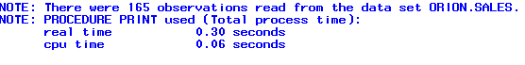

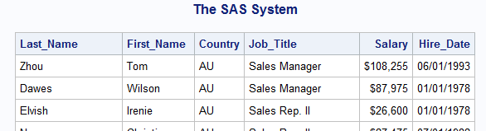

5.2 USER-DEFINED FORMATS

**PROC** **PRINT** DATA=ORION.SALES;

VAR EMPLOYEE_ID SALARY COUNTRY

BIRTH_DATE HIRE_DATE;

FORMAT SALARY DOLLAR10.

BIRTH_DATE HIRE_DATE MONYY7.

COUNTRY $CTRYFMT.;

**RUN**;

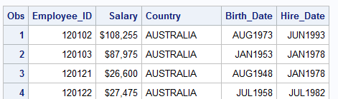

**proc** **format**;

value tiers **0**-**49999**='Tier 1'

**50000**-**99999**='Tier 2'

**100000**-**250000**='Tier 3';

**run**;

**PROC** **PRINT** DATA=ORION.SALES;

VAR EMPLOYEE_ID SALARY COUNTRY

BIRTH_DATE HIRE_DATE;

FORMAT SALARY TIERS.

BIRTH_DATE HIRE_DATE MONYY7.

COUNTRY $CTRYFMT.;

**RUN**;

